
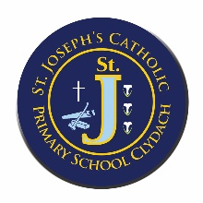
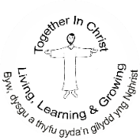
ST JOSEPH’S CATHOLIC PRIMARY SCHOOL, CLYDACH
YSGOL GYNRADD GATHOLIG SAN JOSEFF, CLYDACH

“Together in Christ, Living, Learning and Growing”

“Byw, dysgu a thyfu, gyda’n gilydd yng Nghrist”

Annual Governor’s Report Autumn 2026

The Governor body works closely with our team of committed staff to review and evaluate our school’s progress and plan our future priorities. The governing body are keen for parents and pupils to have an opportunity to engage with us in developing the school for the benefit of all. To this end we hope that you find this report of interest and encourage any comments or questions that you may have.
The Governing body are always very thankful for the support shown by parents, grandparents and carers and the part they play in our school family. Our Friends of St Joseph’s parent group have worked really hard this year raising funds and supporting activities for the pupils. The Governors wish to thank all connected with the school for their work during the past year and appreciate your continued support.
The Chairperson of Governors also thanks the Governing Body for its support over the past year by attending meetings, formulating policies and making important decisions.

Mission Statement
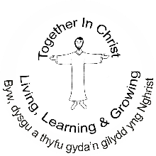
‘Together in Christ - Living, Learning and Growing.’
School Aims
- To provide a living and working example of a Catholic Christian Community.
- To create a pleasant, secure and stimulating environment in which everyone has the opportunity to develop spiritually, morally, socially, emotionally, physically and intellectually in an ethos informed by Catholic Christian values.
- To enhance the ethos of the school by fostering Catholic Christian values and actions through caring, warm and compassionate attitudes from staff, governors, parents and children.
- To nurture in all persons positive attitudes to learning enabling them to adapt to new ideas and methods and thereby achieve their full potential through the acquisition of relevant knowledge and skills.
- To help all pupils develop lively, enquiring minds, the ability to question and argue rationally and apply themselves to tasks and physical skills.
- To help pupils acquire knowledge and skills relevant to adult life and employment in a fast changing world.
- To promote equality of opportunity within the school and respect for all irrespective of sex, nationality, colour, creed, background, and intellectual ability, emotional, social or physical handicap.
- To preserve and develop our own cultural identity within Wales, while at the same time promoting an awareness of and respect for cultures and creeds different from our own.
- To foster links with the Parish, wider community, local businesses and industry.

Our aims will be achieved by:
- Supporting one another.
- Sharing gifts, talents and resources with all.
- Showing respect for the family, for life, for truth, for the property of others and for each person’s contribution.
- Enabling and empowering one another to become living witnesses to Christ.
- Developing children’s basic skills, including Literacy, Numeracy and ICT.
- Developing bilingualism and the Cwricwlwm Cymreig.
- Developing skills and knowledge in Science.
- Helping pupils understand and relate to their environment through Geography, History, Sustainable Development and Global Citizenship.
- Developing, refining and expressing an appreciation of Drama, Music, Literature and other Creative Arts and Crafts while acquiring a wide variety of skills in these areas.
- Developing children’s physical skills and positive attitudes to health through Physical Education and Health Education.

GOVERNING BODY

The Chairperson of Governors is Mr. P. Relf, C/O St. Joseph’s Catholic Primary School, Pontardawe Road, Clydach, Swansea, SA6 5NX.
The Governors of the School are:
Name Category Term of Office Expires
Mr. P Relf (Chair) Foundation Governor October 2028
Mrs. Kirsty Smith (Vice Chair) Foundation Governor November 2029
Mrs. D. Ryan Foundation Governor September 2029
Mrs. Lucy Thomas Local Council Representative November 2026
Fr Saji Foundation Governor April 2028
Mr Sibi Xavier Foundation Governor April 2028
Mrs. Samantha Jones Parent Governor May 2026
Mrs. C. James Teacher Governor September 2026
Mrs. J. Walker Support Staff Governor May 2026
Mrs. M. Mort Headteacher
There are currently two Foundation Governor positions that are in the process of being filled.

The Foundation Governors are appointed by the Trustees of the Diocese of Cardiff/Menevia.
The L.E.A. Representative is appointed by the City and County of Swansea. Teacher, Staff and Parent Governors are elected by teaching staff, associate staff and parents respectively. They are not delegates of these groups and cannot be mandated by the groups they represent to support a particular position with which they do not agree. The next election of Parent Governor will take place in the Autumn Term 2026.
The Clerk to the Governing Body is Ms. Helen James, the School, Administrative Officer.

A NOTE FROM THE CHAIR OF GOVERNORS - Mr. Paul Relf
As we start a new academic year, we welcome back returning and new students to the school.
As we recommence our studies, within the St Joseph’s Community, we remember very much our school motto of Together in Christ, Living, Learning and Growing together in the school, our parishes and our homes. We hope you enjoy reading our report will tell you about all the great achievements, work and commitment of our students, staff and parents.
We look forward to the activities for the coming year together.

THE ROLE OF THE GOVERNORS IN THE RUNNING OF THE SCHOOL
The day-to-day management of the school is the responsibility of the Headteacher. The Governors deal with admissions, decide how the budget is allocated, appoint new staff, receive reports from the Headteacher, decide how the curriculum is constructed and how the school is run. Decisions are only made after full consultation with the Headteacher, whose professional opinion is always taken into account.

The WORK OF GOVERNORS
Governors’ roles and responsibilities. The Governing Body has a general overall responsibility for the effective management of the school, acting within the framework set by national legislation and with due consideration to the policies of the Local Education Authority. The governors must meet regularly, at least the mandatory once a term. In effect, they meet more often in order to carry out their duties effectively. In addition to the meetings of the full body the governors also work in smaller committees.

COMMITTEES
All these committees are required to keep abreast of current developments and the implications of new legislation. They study and evaluate documents and Committees must report to the full Governing Body, although those with delegated powers are able to make certain decisions in their own right. All committee meetings are minuted and the minutes circulated to all governors.

CURRICULUM & STANDARDS
This committee meets to debate curriculum developments in the school. All governors are linked with Curriculum Coordinators who make recommendations and offer explanations to the members of this committee. On an annual basis the governors and staff join together to evaluate the progress made (over the previous twelve months) in meeting the targets agreed in the School Development Plan. Following this discussion, the new Development Plan for the year is created.

HEALTH & SAFETY AND PREMISES
This committee is responsible for the premises and the maintenance requirements, including ensuring that all Health and Safety and Safeguarding regulations are observed. This involves careful monitoring and regular site visits.

FINANCE
This committee is responsible for overseeing the school’s budget and deciding where expenditure would be most effective. In addition the committee is concerned with any aspect of management that involves people – be they pupils, staff or volunteer helpers, including appointments and disciplinary matters.
The School Budget and School Fund Account are available to view, on request from the School Office.Community Committee

ETHOS AND COMMUNITY
This committee is responsible for establishing and developing links with the local community and parishes. They are also reponsible for directing the mission and purpose of the school.

In addition to the committees some governors carry out specific roles in certain areas.

Paul Relf - LAC, Safeguarding, Science
Delia Ryan - Maths & Numeracy, Data, Health & Safety
Kirsty Smith - Religious Education, Prayer & Liturgy, ALN, Transition
Fr Matthew Saji - Catholic Life & Mission
Maria Ascensio-Cubero - Humanities, Eco, EAL
Lucy Thomas - Expressive Arts, Health & Wellbeing
Samantha Jones – ALN, Literacy, Language & Communication.
Sibi Xavier - ICT & DCF (Digital Competency Framework)
Vacancies – Humanities, EAL,

The non-confidential minutes Governors’ Meetings, including committees, are available in the school office for parent/carers to read.

Governors’ Expenses
Although it is now possible for governors to claim expenses, once again no claim has been charged to the school.

SCHOOL: St. Joseph’s RC Primary (Clydach)
STATEMENT OF ACTUAL EXPENDITURE 2025/26 FINANCIAL YEAR
 | Delegated Expenditure | Non-Delegated Expenditure | Total Net Expenditure
 | £ | £ | £
Teachers Salaries | 674,867 | 12,297 | 687,164
Salaries | 323,710 | 35,381 | 359,091
Other Employee Costs | 1,413 | 584 | 1,997
Premises | -2,388 | 0 | -2,388
Transport | 0 | 135,833 | 135,833
Supplies & Services | 209,931 | 0 | 209,931
Recharges | 8,561 | 177,976 | 186,537
Gross Expenditure | 1,216,094 | 362,071 | 1,578,165
Grant Income | -197,414 | 0 | -197,414
Other Income | -60,338 | 0 | -60,338
Gross Income | -257,753 | 0 | -257,753
Net Expenditure | 958,342 | 362,071 | 1,320,413
RESERVES: |  | £
FINAL FORMULA ALLOCATION: |  | 1,089,162
TOTAL NET EXPENDITURE: |  | 958,342
TRANSFER TO / (FROM) RESERVES: |  | 130,820
OPENING BALANCE ON RESERVES 01/04/25 |  | 171,475
CLOSING BALANCE ON RESERVES: 31/03/26 |  | 302,295
School term and holiday dates 2026/27

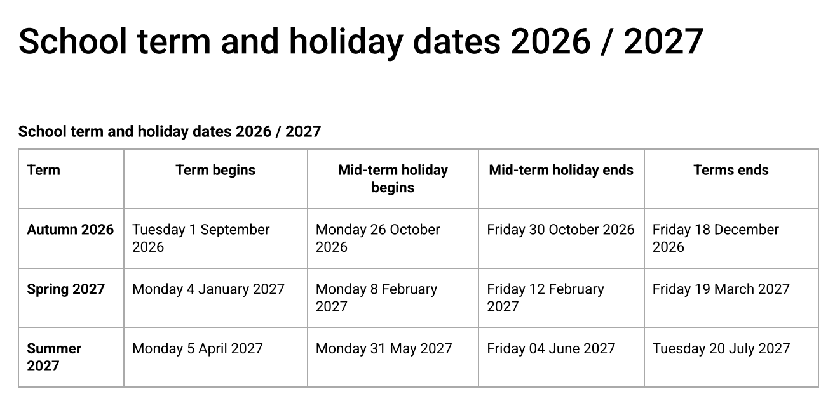

Bank holidays:
Good Friday: 26th March 2027
Easter Monday: 29th March 2027
Early May Bank Holiday: 3rd May 2027
Spring Bank Holiday: 31st May 2027

Please note that this calendar is subject to any changes that may arise as a result of Welsh Government issuing a direction on term dates. Swansea Council does not accept any liability for any losses incurred in respect of altered holiday arrangements following changes to the timetable in any direction issued by the Welsh Government.

School Prospectus Attendance Analysis
Period: 03/09/2025 to 17/07/2026
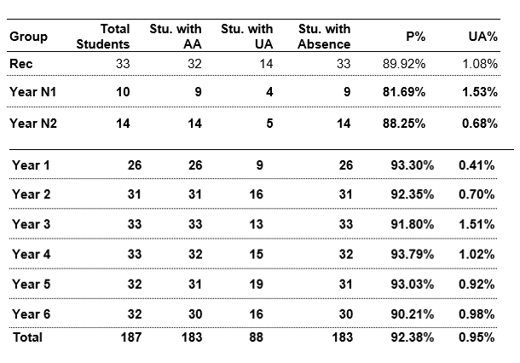

ANNUAL ATTENDANCE STATISTICS 2025 – 2026
A number of measures have been introduced to improve attendance for example, the setting up of an absence line to report absence on the first morning of absence and a text message or telephone service if no absence is recorded. At St Joseph's Catholic Primary School attendance is monitored and reviewed regularly by senior leaders and discussed with the Education Welfare Officer to ensure early intervention for any pupils experiencing attendance difficulties. Our attendance for 2025-26 has shown continued improvement, with whole-school attendance reaching 93.9% during Autumn 2025 and Spring 2026. The school's expectation of at least 95% attendance and we are committed to working in partnership with families to ensure every child attend school regularly and arrives punctually, enabling them to participate fully in all aspects of school life. Attendance information regarding holidays etc. is on the school website

SAFEGUARDING/ MEDICINES
When medicines are to be administered in school it is essential that safe procedures are established which are acceptable to appropriate school staff involved. When requesting that medication be administered to their child parents should always complete a form available from the school office giving the child’s name and class, clear instructions on the dose to be administered to the child, the time to be given and for what period. Medication must be in its original packaging including the prescriber’s instructions. Only the prescribed/recommended dose will be administered, this cannot be changed unless written instructions are given from a medical professional. The form should be signed by the parent or guardian and retained in the school office for reference by staff involved.

In cases where the child’s medical needs may be greater than those of their peers, the Headteacher may request that an individual Healthcare Plan be prepared if applicable by the school Nurse. In such cases, consultations on the Plan will include the school, health service practitioners (i.e., school nurse) and the parents/guardians. This will also clarify the extent of responsibility taken by the school. The Headteacher will be responsible for managing the administration of medicines and drugs with the agreement of named members of staff. Staff should be able to act safely and promptly in an emergency situation, as well as with the routine administration of medicines. Members of staff will be asked to volunteer to be involved in the administration of medication. Only those members of staff who have current First Aid qualifications will be required to act in an emergency. Other members of staff who are willing to dispense medicines to pupils i.e., Teaching Assistants, Class Teacher, Office staff, should be advised of the correct procedure by the Headteacher. It is the responsibility of the Headteacher to ensure that new members of staff receive appropriate training.

CHILD PROTECTION
The school policy continues to be implemented by all staff in line with guidelines and procedures recommended by the Education Authority.
We have designated senior persons for child protection who have received appropriate training and support for this role. (Headteacher / ALNCO). We have a nominated governor responsible for child protection (Chair of Governors). Every member of staff (including temporary and supply staff and volunteers) and governing body knows the name of the designated senior person responsible for child protection and their role. All staff and Governors have been provided with training for child protection.

FIRST AID
Mrs. C. Brett-James is our official nominated trained First Aider. All teaching assistants are trained first aiders.

HEALTH AND SAFETY
Health and safety procedures in the school are regularly reviewed and discussed termly by the Governors. There is a site walk every term with the Governors Buildings Committee and Head/ Deputy Head. There is a regular review of the school’s Risk Assessments and Fire Safety Risk Assessment and Emergency Action Plan. Termly fire and evacuation drills are carried out. We are renewing our Lockdown policy and procedures this term and these will be sent out at the end of September.

SCHOOL SECURITY
The school site is fully secure during pupil hours. Entry to the main school grounds is only possible through the main gates which has a coded entrance. All visitors are required to ring to gain entry.
Entry to the main building by the main door is only possible for those in possession of a code. Other visitors have to ring to gain entry. All visitors to the Early Years Block have to ring to gain entry.

It is essential that all visitors (including parents) report to the school office upon arrival at the school and sign in. Parents/visitors are not allowed to walk through the school unless with a member of staff. Children know that they are not allowed to open the door to strangers.

ASSAULTS
There have been no physical assaults on members of staff.

VANDALISM
There was no vandalism in 2025/ 2026

BUILDINGS
The Governors are committed to providing a safe and attractive environment for all children, staff and visitors to the school. The school toilets in the main school and Nursery/Reception building are modern by school standards and there is a disabled toilet in the Nursery/ Reception block. They are kept clean by using

professional cleaners and materials. There is liquid soap in all the toilets. We have developed a ‘nurture’ room called Ralph’s Room where counselling and pupils can have dedicated time with one-to-one programs, including sensory programmes. We have had an outdoor shelter area built outside Year 2 and are going through planning permission to create one for Reception class, Year 1 and repair the Nursery shelter. We are also looking to crate outdoor shelters/areas for the four Upper classes too. New flooring has been laid in the Ealy Years block, Year 4 and the Year 5/6 corridor.



STAFFING
St. Joseph’s is fortunate to have a team of talented, enthusiastic and dedicated individuals who do their utmost to provide the best possible education for all our children.

Class Number of pupils Teacher
Nursery 12 Mrs. Rachel Ryan
Reception 33 Mrs. R. Weaver
Year 1 28 Mrs. C. Morgan
Year 2 30 Mrs. V. Hussell and Mrs. R. Crowney
Year 3 33 Mr. J. Reed
Year 4 33 Mrs. C. Brett-James
Year 5 31 Mrs. R. Torrance
Year 6 33 Mr. P.Maddock

Individual teachers have the following additional responsibilities:
Name Responsibilities
Mrs. M. Mort Headteacher
Mrs. R.Crowney Deputy Headteacher, ALNCo Manager,
Curriculum Leader for Foundation,
Coordinator for Staff Development
Mrs. C. Brett-James EAL Manager
Curriculum Lead for Religious Education
Curriculum Lead for Health and Wellbeing.
Data Analysis and Assessment, Recording & Reporting Manager
Shadow ALNCo
School Council Lead
Mr. J. Reed Curriculum Leader for ICT & DCF.
DCF Lead.
Mrs. R. Torrance Curriculum Lead for Language, Literacy & Communication
Mini-Vinnies Lead
Mrs. R. Weaver Curriculum Leader for Languages, Literacy & Communication -
Welsh and Additional Language
Criw Cymraeg Lead
Mrs. R. Ryan Curriculum Leader for Expressive Arts
Mrs. C. Morgan Curriculum Lead for Science,
Mentor for Student Teachers and N.Q.T.s
Eco Lead
Mr. P. Maddock Curriculum Leader for Maths & Numeracy
Mrs. V. Hussell Curriculum Leader for Humanities

School Clerk Ms. Helen James
Teaching Assistants Mrs. J. Walker,
Mrs. H. Rowden-Cooper,
Mrs. H. Weaver
Miss J. Davies
Mrs. S. Carr
Miss M. Brougham
Mrs. F. Thomas
Mrs. N. Chenard
Mrs. C. Johnson- Rasbridge
Mrs. A. Nowakowska
Miss Aimee James
Caretaker Mr. C. McGillycuddy
Cleaners Mrs. N. Chenard, Mr. S. Nowakowksi
Kitchen Staff Ms L ……., Mrs. J. Maher, Mrs. D. Jones, Ms. B. Dawson

Parent Helpers
Very special thanks to those who give up their precious time to help in school and on educational visits.

FRIENDS OF ST. JOSEPH’S
The work of FOSJ is greatly appreciated by all at the school. Governors and Staff wish to encourage all parents to join regular meetings and functions. The FOSJ organize fun activities for pupils and raise money for resources, organise refreshments and stalls for Sports Day and other events and arrange for parents to come in to do jobs around the school.

CURRICULUM
At St. Joseph’s we believe in a creative curriculum with literacy and numeracy at its heart. The school has developed its curriculum in line with the Curriculum for Wales using Essential Questions to lead a thematic approach. Pupils at St Joseph’s study all subject areas including Religious Education, Languages, Literacy & Communication, Maths & Numeracy, Science & Technology, Welsh, Humanities, Expressive Art, and Health & Wellbeing. All curriculum areas and are regularly reviewed and developed by staff and governors. The school development plan includes specific school strategies which are also reviewed. A particular emphasis is being developed within the use of key and integral skills.

RELIGIOUS EDUCATION
St. Joseph’s is a Catholic Christian Community in which an understanding of our Beliefs and Faith is of vital importance. The ‘Know you More Clearly’ Religious Education Directory provides a framework for all classes to follow through the Knowledge Lens Content and Expected Outcomes set out. Daily assemblies incorporate a variety of experiences which help develop the Catholic Christian ethos of St. Joseph’s. The importance of reflection, prayer, care and concern for others is actively encouraged and we use the CES (Catholic Education Service) Prayer & Liturgy Directory ‘To love You more dearly.
The school supports a range of charities and seeks to heighten awareness of global needs. In-line with Diocesan policy the school has adopted the Catholic Pupil Profile which helps develop pupils into intellectually competent, virtuous, and compassionate individuals who are "good at being human". This framework guides schools in nurturing students' spiritual, moral, and social development by focusing on specific virtue pairs each half-term and integrating them into the curriculum, Collective Worship, and daily school life. We also practise daily meditation linked to our Health& Wellbeing curriculum to pray, quieten the mind and reflect on themes like forgiveness, hope, love, gratitude and compassion which can build emotional strength.

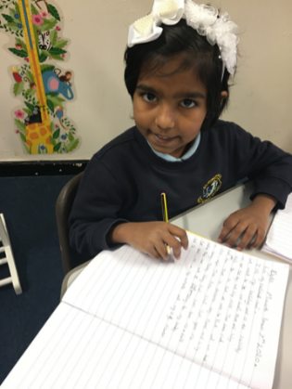

LITERACY AND COMMUNICATION
Reading is given a high priority throughout the school with fiction and reference materials readily available in every class and the school library. We also use an online product called ‘Reading Eggs’ which children can access at school and at home. Parents are expected to share reading with their children in order to develop an interest in and a love of reading. Pupils are encouraged to write in a wide range of styles for a variety of audiences and across all curriculum areas. Emphasis is placed on spelling, punctuation, handwriting and presentation within the genre journey with Literacy work linking to the thematic curriculum, where possible. A variety of visits and visitors supported pupils’ work in English / Literacy.

MATHS AND NUMERACY
The acquisition of basic skills and the use of these in a wide range of contexts continues to be our priority in Mathematics. The Abacus scheme is used and is being constantly developed through the purchase of appropriate computer software. Other items of mathematical apparatus were purchased through the year to support the scheme and aid the delivery of the Mathematics & Numeracy curriculum. Problem solving and real-life authentic contexts within mathematics is a focus for all classes.

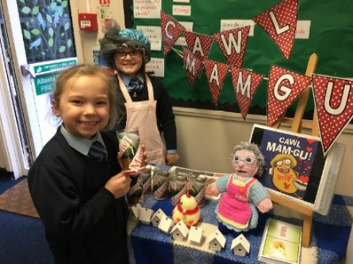
HUMANITIES
Many aspects of History and Geography are taught through themes and Essential Questions. We have been developing our use of the local environment within topic working and there are regular educational visits and visitors to support pupils’ learning in these curriculum areas.

SCIENCE AND TECHNOLOGY
The school is well resourced to deliver the Science and Technology curriculum. Pupils have opportunities to develop and communicate their ideas, using a variety of tools, techniques and materials. Science investigations are linked, where possible, to class themes.

I.C.T. & the DCF
The school has continued to develop the range of hardware and software available to pupils and teachers. All classes from Reception to Year 6 have interactive whiteboards and there is access to iPads, digital cameras and computer microscopes. We have a large number of class laptops which are used on a rota for all classes. The Digital Competence Framework has been implemented in the school and is a priority this year with a new tracking, planning and assessment system. Mr. Jon Reed is the DCF leader within the school and there is a Digital Competence council which is part of the school’s Pupil Action Groups.

LANGUAGES
Welsh is taught as a second language and is used incidentally throughout the school and within the daily Slot Ddrilio. Staff expertise in speaking and teaching the language continues to increase. An advisory teacher for Welsh visits the school regularly. An Wythnos Cwricwlwm Cymreig/ Welsh Week is celebrated every year to celebrate St. David’s Day with a topic/focus decided by pupils and staff through the School Council. This week culminates in an Eisteddfod allowing pupils to share their Welsh cultural experiences with a Chairing and Crowning of the Bard Ceremony, the Bard is chosen from Year 6 poetry entries.

EXPRESSIVE ARTS
Knowledge of famous artists and a range of art styles are cultivated at St. Joseph’s and our displays reflect the high quality of art work. The school is well resourced to teach the Music curriculum with a County peripatetic teacher visiting twice a week to work with each class across the three terms. Singing is an important part of school life with the continued development of the School Choir under the leadership of Mrs. Weaver. All pupils participate in successful Christmas and Easter plays.

HEALTH AND WELL BEING
The school aims to develop pupils’ physical skills fully. There are opportunities to participate in a wide range of activities – Gaelic Football, football, organised games, athletics, cross country running and outdoor adventure activities. Pupils represent the school at Gaelic Football, football and athletics. Regular fixtures are arranged with other schools throughout the year. The Sports Council Pupil Action Group works to ensure that pupil voice is listened to in relation to PE and Games provision.

ALN
The school is successful in its provision for children with Additional Learning needs. The school carefully follow the ALN Code which gives all staff guidance on catering for children in this category. All pupils are assessed and funds are allocated based on an annual audit taken by the City and County of Swansea. Children with Additional Leaning Needs are taught in mainstream classes and are supported in class and also withdrawn and catered for individually or in small groups. Progress is monitored and assessed and full consultation takes place with parents in accordance with the Additional Learning Needs Code of Practice. The consultation process also involves representatives of the Local Education Authority and other schools to which our children transfer.

RELATIONSHIPS & SEX EDUCATION
The school has adopted the Diocesan Relationships and Sex Education Policy for Primary Schools. Ten Ten ‘Live Life to the Full’ resources and the CES RSE guidelines enable RSE to be taught in able to educate the whole person and are following Diocesan advice and also implementing the ‘Fertile Heart’ scheme. Questions from children are dealt with sensitively. A health and hygiene talk with the school nurse is arranged for Year 6 pupils and Year 5 girls during the summer term.

HOMEWORK
Homework is given in accordance with the ages and needs of the children. The cooperation of the home is actively encouraged and greatly appreciated. Homework is primarily set and completed online.

SCHOOL UNIFORM
School uniform requirements are set out clearly in the School Prospectus and on the school website.

BEHAVIOUR
The school expects high standards of behaviour and takes great pride in all pupils’ achievements, behaviour and appearance. A clear policy on behaviour is regularly reviewed. This is available to parents on request. Parents should remember that members of staff need to be informed swiftly if pupils are concerned, worried or apprehensive about any matter relating to school. The school places an emphasis on treating others as we wish to be treated ourselves and foster a climate built on mutual kindness, empathy, and respect for self, others, and property encourage pupils to take accountability for choices, and engage positively with school routines. The Merit Award System supports this, certificates being awarded at a special weekly assembly and a cup awarded each term to the most successful of the four house teams.

SECURITY ARRANGEMENTS
Security arrangements for pupils, staff and school premises are continually reviewed and improvements sought. Officers of the Diocese and the Local Education Authority are consulted on any changes made and all work is carried out by contractors recommended by these representatives. Entry to the main school grounds is only possible through the main gates which have a voice entry system. Entry to the main building by the main door is only possible for those in possession of a code. Other visitors have to ring to gain entry.
It is essential that all visitors (including parents) report to the school office upon arrival at the school and sign in. Children know that they are not to open the door to strangers.

AFTER SCHOOL CLUBS
A number of after paid for school clubs are usually run during the school year on Mondays and Tuesdays 3:20-
4:20p.m. A form is sent out at the beginning of each term to secure a place and clubs have a limit of 20 pupils.

ACCESS FOR DISABLED PUPILS
Ramps make wheelchair access possible to all classrooms and washroom facilities for disabled persons exist in the Early Years Block. The school has an accessibility plan which aims to improve access to the school by those with disabilities. The school’s Mission Statement and Aims clearly state equality for all pupils admitted to the school.

SCHOOL PROSPECTUS
The current 2026/27 School Prospectus is on the school website and is available to all parents on request.

COMMUNITY DEVELOPMENT
There is a strong tradition of close links with the local community. Pupils regularly visit places of special interest in the locality and surrounding areas. The school is an integral part of St. Benedict’s Parish and pupils attend Mass regularly. The school hosts a Christmas ‘Coffee & Carols’ afternoon for senior members of the parish and pupils entertain our visitors with singing. The school has links with the police and School Nurse who regularly visit and also with local businesses and industries. Ways to strengthen and develop these links are constantly sought.

ADMISSIONS
All admissions are considered in accordance with the School Admissions Policy.
A new admissions policy in line with Diocesan Policy has been ratified by the Governors and is on the school website.

INSPECTION OF ST. JOSEPH’S- Summary OCTOBER 2019
St Joseph’s Catholic Primary School has a warm, caring and nurturing environment for pupils. This contributes significantly to pupils’ strong levels of wellbeing and helps them to develop as caring, polite and considerate individuals. Parents, pupils, staff and governors contribute successfully to the strong sense of community that exists in the school.
Most pupils make good progress from their starting points and develop their literacy and information and communication technology (ICT) skills well. They develop their numeracy and Welsh language skills appropriately. Nearly all pupils have positive attitudes towards their learning and behave exceptionally well. Nearly all concentrate purposefully in lessons and persevere with their tasks.
The headteacher promotes a clear vision for the school and receives effective support from the senior leadership team and governing body. Self-evaluation processes are successful in identifying strengths and areas for development.

Inspection area Judgement
Standards Good
Wellbeing and attitudes to learning Good
Teaching and learning experiences Good
Care, support and guidance Good
Leadership and management Good

CATHOLIC SCHOOLS INSPECTION SECTION 50 – JANUARY 2024
What the school does well;
All at St. Joseph’s Catholic Primary School understand and embrace the Catholic identity and mission of their school, living out the school mission statement; ‘Together in Christ, Living, Learning & Growing,’ the school is a welcoming, inclusive Christ-centred learning community.
• School leaders, governors and clergy are excellent role models, dedicated and committed to Catholic
education.
• Pastoral care is a strength of the school; there is a lived sense of family and community evident in the
quality of relationships and the love and care shown for all pupils.
• Pupils demonstrate a deep sense of respect for those of other faiths, religions and none. The behaviour
of pupils is exemplary both in lessons and throughout the school.
- Pupils throughout the school demonstrate independence in their learning which is cross curricular in nature, for example, the pupils’ digital skills are particularly strong. What the school needs to improve
• To continue to effectively plan, implement and monitor the Religious Education Directory and share good
practice with others.
• To develop assessment processes in accordance with the Religious Education Directory curriculum, to
accurately measure pupils’ attainment and inform future planning and next steps
The highly successful reports can also be attributed to the strong partnership that exists between
governors, staff, parents and parishioners.

SDP
The School Development plan set the following priorities this year:
Targets and Strategies for Our Priority Areas 2026/27

By the end of July 2027, we aim to:

1 | To develop our use of the Religious Education Assessment Toolkit in RE and embed the CES Prayer and Liturgy document ‘To Love you more Dearly’, in line with diocesan requirements.
2 | To develop independent learners who actively influence their learning, understand their progress and identify their next steps.  This priority will be an overarching priority which will focus on creating a culture where pupils are active partners in the learning process. Teachers will provide meaningful opportunities for learners to contribute to curriculum planning, shape enquiries and make choices about how they demonstrate their learning. Alongside this, a consistent approach to assessment for learning, feedback and reflection will help pupils develop a clear understanding of their progress and next steps. Each AoLE Lead will take responsibility for the development of independence within their area.

