
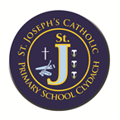

St. Joseph’s Catholic Primary
School, Clydach
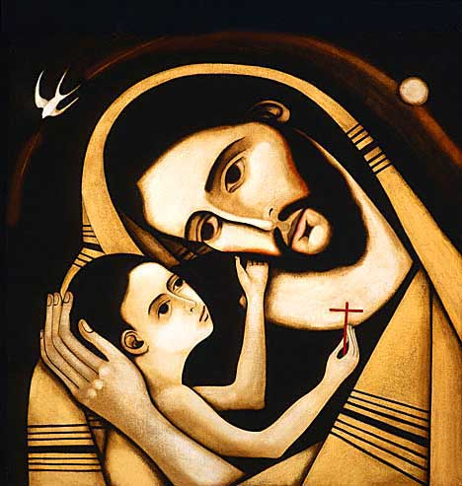

2012 - 2013

Uniform Policy

Date of Review: June 2026

Signature:

School Mission Statement: ‘Together in Christ – Living, Learning and Growing.’

St. Joseph’s Catholic Primary School students wear their uniform with pride. Our uniform shows that we are part of the St. Joseph’s Primary School community. We have the highest expectations from our students with regards to school uniform and appearance, and strongly believe that our high standards promote positive behaviour, support effective teaching and learning and contribute to the ethos of the school.

School Uniform
We have school uniform and we encourage all our children to wear their uniform smartly. All items of uniform must be labelled. It consists of the following:

WINTER UNIFORM – September to Easter Break

BOYS
• Blue shirt – short or long-sleeved
• Navy jumper
• Navy trousers
• Completely flat, plain, black shoes - no trainers.
• School tie (Available from School Reception Office. Cost £7.50)
GIRLS
• Blue shirt– short or long sleeved
• Navy jumper or cardigan (school logo optional)
• Plain navy pinafore/ or navy long trousers / or navy knee length skirt
• Completely flat, plain, black shoes- no trainers.
• School tie (Available from School Reception Office. Cost £7.50)

SUMMER UNIFORM – Easter Break to July
BOYS - Polo shirts / navy shorts or trousers

GIRLS - Blue gingham Summer Dress or polo shirts with navy shorts/ trousers/skirt.

*Completely flat, plain, black shoes - no trainers.

PE Kit

Pupils need an appropriately labelled PE kit consisting of the following:
- Navy shorts/joggers
- blue polo shirt
- trainers
- navy sweatshirt (logo optional)

NO HOODIES ARE ALLOWED – except when the Leavers hoodies are given out.
School uniform is optional for Nursery Class
In Reception and Nursery pupils can wear rea school gym kit – blue polo short and navy joggers/shorts with black trainers EVERY DAY.

Items may be ordered from

Call 01792 796880 / 01792 771070
or email sales@bergoni.co.uk

https://www.schooltrends.co.uk/collections/stjosephsrcprimaryschoolsa65nx
J& S Embroidery East end garage Clydach

All items of school uniform must be clearly labelled with name tapes sewn in.

General notes on appearance:

Jewellery: -
- Jewellery should not be worn or brought into school.
- No other body piercing, i.e. nose piercings are allowed.
Hairstyles:
- Hair should be one natural colour, no hair dye.
- The style should be appropriate for school, hair should not obstruct pupil’s vision.
- Pupils with long hair must be tied back.
Students must not wear:
- Trainers are NOT allowed to be worn at any time other than for PE lessons and clubs.
- Make up and nail varnish should NOT be worn to school.
Non-compliance with the uniform and appearance policy:
Parents of students who do not wear the correct uniform, will firstly be contacted and reminded of the uniform policy. If the situation continues the parent will be contacted and requested to bring in a change of clothes for their child .Students who wear make-up/nail varnish or excess jewellery will be required to remove these.

*In Reception and Year 1, shoes with Velcro fastenings are strongly recommended.
From Year 2, children can wear shoes with buckles and laces. Children can only have laces if they can tie them up themselves.

Child Protection - The United Nations Convention on the Rights of the Child (CRC) is at the heart of our school’s planning, policies, practice and ethos. As a rights- respecting school we not only teach about children’s rights but also model rights and respect in all relationships –
Linked to Articles 3, 12, 16, 19, 20, 21, 25, 27, 28, 30 34, 36, 39, 42 (CRC)

