
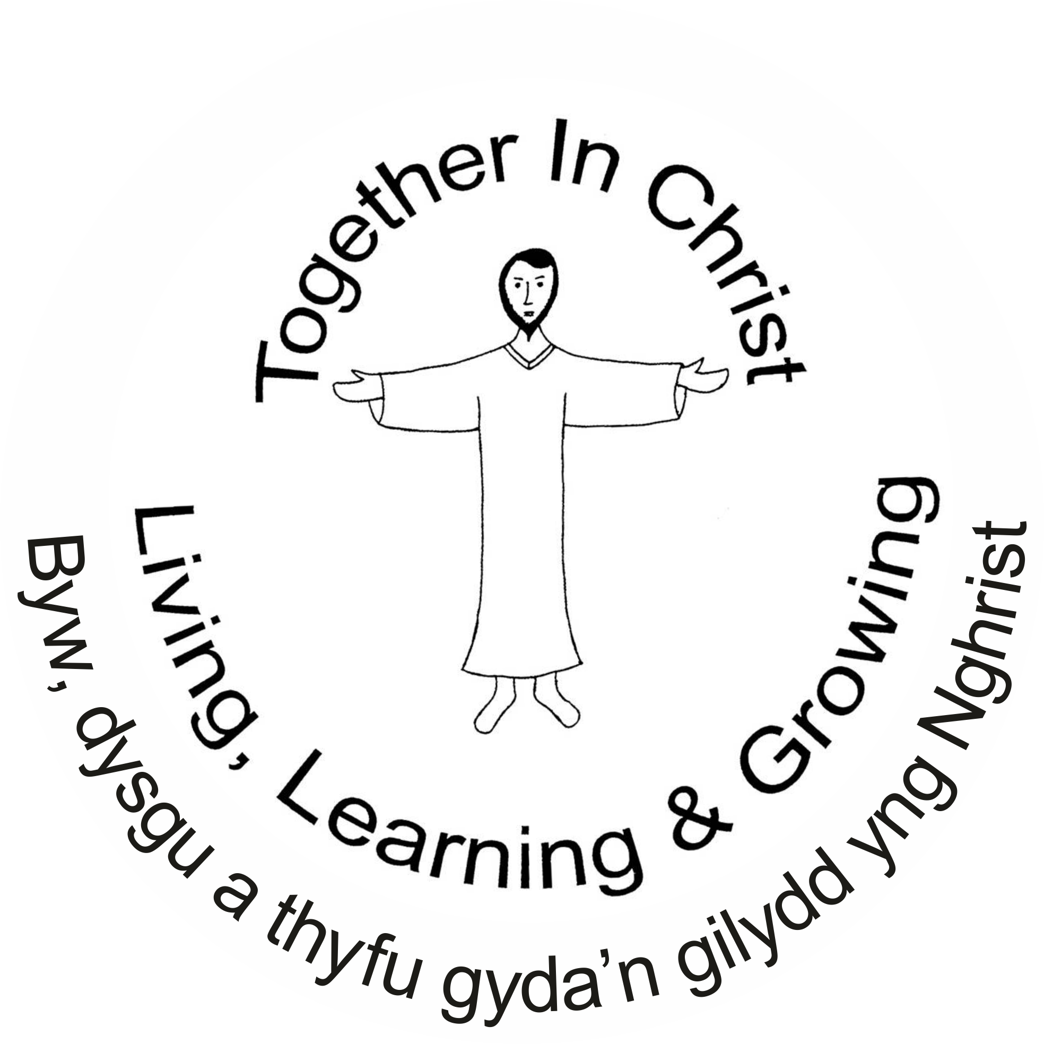


April 17th 2026

St. Joseph’s Primary School
School Attendance: 93%
Reception: 99.2 Year 1: 85.4% Year 2: 96.8%
Year 3: 91.4% Year 4: 87.1% Year 5: 93.5% Year 6: 96%
Winning Class
for Attendance:
Nursery:
100%
Ardderchog!

Upcoming dates:

Saturday April 18th 10 am
PE SKILLS Training Day for staff and parents in school.

Tuesday 21st April
Yr 4 trip to Aberavon Beach

Thursday 23rd April
Yr 3 trip to the Waterfront Museum

Friday 7th May
Image Theatre in school ‘Dr Dolittle’

Friday 19th June
Sports Day (a.m.) & Gaelic Football Festival all day(more information to come)

Friday 19th June
Sunflower Day (theme to be decided by the pupils)

Jesuit virtues for
March/April:

Grateful & Generous



Updates of the week:
Welcome back to a busy summer term and I hope you had a happy and holy Easter.
We are raring to go at St Joseph’s and have a busy term ahead with events and ideas for change in September. A huge thank you to all staff who are always on board with looking to the future to make St Joseph’s the best we possibly can for all of our pupils.

Letters for the new, summer term’s, clubs have gone out and club lists will start again from Monday. If your child was in a club last term they will have needed to reapply and pay to access the club this term.

Club times are 3.20- 4.20PM Please be on time to collect your child from the main gate, diolch.
There are no clubs during HALF TERM – May 25th – 29th and the last week of clubs will be the week of July 6th.

MONDAY | TUESDAY
REC/Y1/2: LEGO CLUB | REC/Y1/2: BIBLE STORIES
Y3/4: ART CLUB | Y3/4: INDOOR & OUTDOOR GAMES
GY5/6: CREATIVITY & FITNESS | Y5/6: GAELIC FOOTBALL

Important dates are on the calendar on our school website. Photos are on the ‘News & Events’ part of the website of all recent events.

Information for Year 6 pupils – please read. https://www.j2e.com/st-josephs-catholic-primary-school15/Mary/Wales+Vinnie+Camp+August+2026.pdf/ Yr 6 Wales’ Vinnie Camp

ALL WELCOME – TOMORROW!!!!!!!!!!
Developing PE skills using small sided games. The course will take place on Saturday 18th of April, at St Joseph’s Primary School, Clydach a 10am start. Suitable for parents, teaching staff and student teachers. It will include outdoor activities so bring appropriate sports gear. Contact maddockp@hwbcymru.net. Huge thanks to Mr. Maddock for giving up his time.
​1STJPS ICGG Dual St Josephs April 2026 (1).docx​

Please see the important changes to our attendance/absence arrangements that have been text out and are on the website. Thank you for your cooperation. https://www.j2e.com/st-josephs-catholic-primary-school15/Mary/Absence+changes+letter.pdf/

