



March 20th 2026

St. Joseph’s Primary School
School Attendance: 92.3%
Reception: 89.4% Year 1: 97.1% Year 2: 89%
Year 3: 95% Year 4: 90.3% Year 5:94.8% Year 6: 93.2%
Winning Class
for Attendance:
Nursery:
97.9%
Ardderchog!

Upcoming dates:

EASTER:
Monday 23rd March
9:30 Nursery & Rec. Play
1:30 Years 1 & 2 Play

Tuesday 24th March
9:30 Years 3 & 4 Play
1:30 Years 5 & 6 Play

Wednesday 25th March
9:30 Easter Bonnet Parade Nursery-Year 2.

Thursday 26th March
9:30 Easter Mass at St. Benedict’s.

Easter Holidays:
Mon 30th March – Friday 10th April

INSET DAY Mon 13th April

Jesuit virtues for
March/April:
Intentional & Prophetic.

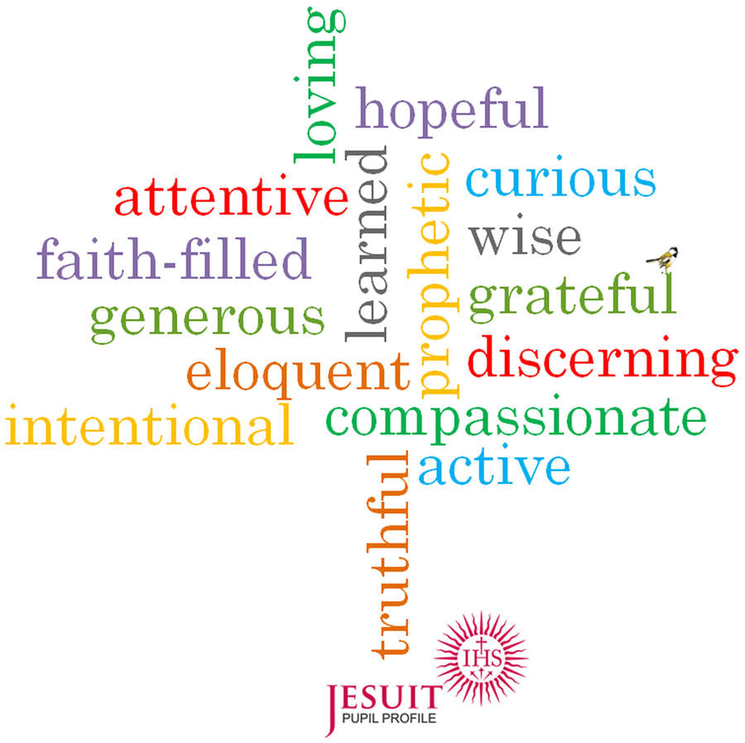

Updates of the week:
PLEASE NOTE that the Creative Writing after school club has to be cancelled on Monday 23rd March as Miss Fran is on a course.

Club times are 3.20-4.20 p.m. Please be on time to collect your child from the main gate, diolch.
After Easter club lists will start anew. Letters for the new, summer term’s clubs will go out after Easter and no places will be kept in advance.

We are looking forward to welcoming you for our Easter plays and celebrations next week in the Hall. These plays help us all to remember the true meaning of Easter and to prepare us for Holy week. Entry is £2 per person – please remember to bring cash for entry to the play.

Important dates are on the calendar on our school website. Photos are on the ‘News & Events’ part of the website of all this week’s events.

As part of our Lenten preparations each class has its own CAFOD collection pot. Our goal is £231, which is enough to support a family for a year through the floating garden project. 'A better world needs all of us'.

We are collecting items for our Easter Hampers as part of our Easter celebrations.

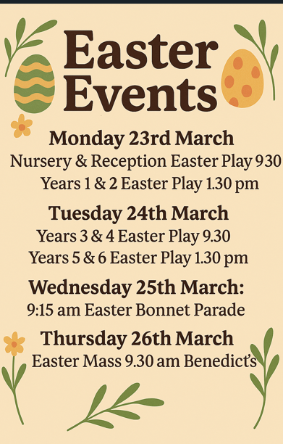

Please see the important changes to our attendance/absence arrangements that have been text out and are on the website. Thank you for your cooperation – this is something that County have been chasing us to change for a while. https://www.j2e.com/st-josephs-catholic-primary-school15/Mary/Absence+changes+letter.pdf/

