



March 13th 2026

St. Joseph’s Primary School
School Attendance: 93.3%
Reception: 92.7% Year 1: 96.7% Year 2: 86.8%
Year 3: 93.9% Year 4: 94.4% Year 5: 97.7% Year 6: 93.2%
Winning Class
for Attendance:
Year 5:
97.7%
Ardderchog!

Upcoming dates:

EASTER:
Monday 23rd March
9:30 Nursery & Rec. Play
1:30 Years 1 & 2 Play

Tuesday 24th March
9:30 Years 3 & 4 Play
1:30 Years 5 & 6 Play

Wednesday 25th March
9:30 Easter Bonnet Parade Nursery-Year 2.

Thursday 26th March
9:30 Easter Mass at St. Benedict’s.

Easter Holidays:
Mon 30th March – Friday 10th April

INSET DAY Mon 13th April

Jesuit virtues for
March/April:
Intentional & Prophetic.



Updates of the week:
Club times are 3.20-4.20 p.m. Please be on time to collect your child from the main gate, diolch.
Letters for the new, summer term’s clubs will go out after Easter and club lists will start again.
Important dates are on the calendar on our school website. Photos are on the ‘News & Events’ part of the website of all this week’s events.

As part of our Lenten preparations each class has its own CAFOD collection pot. Our goal is £231, which is enough to support a family for a year through the floating garden project. 'A better world needs all of us'. Just each child bringing in £1 will make this total. Please support.

Thank you to everyone for your support during Parents Evening. I hope the new format worked well – please give feedback on anything that didn’t.

Thank you to Mrs Morgan and the ‘Young Apprentices’ who made and sold the Mother’s Day items. They ran out early so sorry for any disappointment.

We are beginning to collect items for our Easter Hampers as part of our Easter celebrations. Please see the dates of our Easter plays etc. Entrance to our Easter play is £2 per person – please bring cash on the day – all money to school funds.

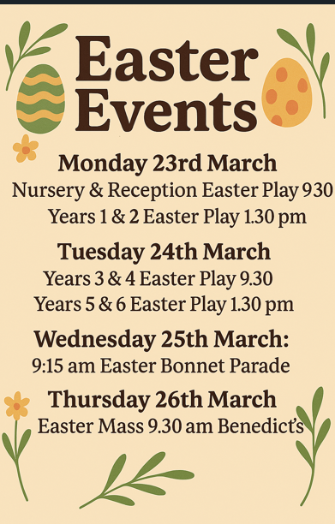

Please see the important changes to our attendance/absence arrangements that have been text out and are on the website. Thank you for your cooperation – this is something that County have been chasing us to change for a while. https://www.j2e.com/st-josephs-catholic-primary-school15/Mary/Absence+changes+letter.pdf/

