
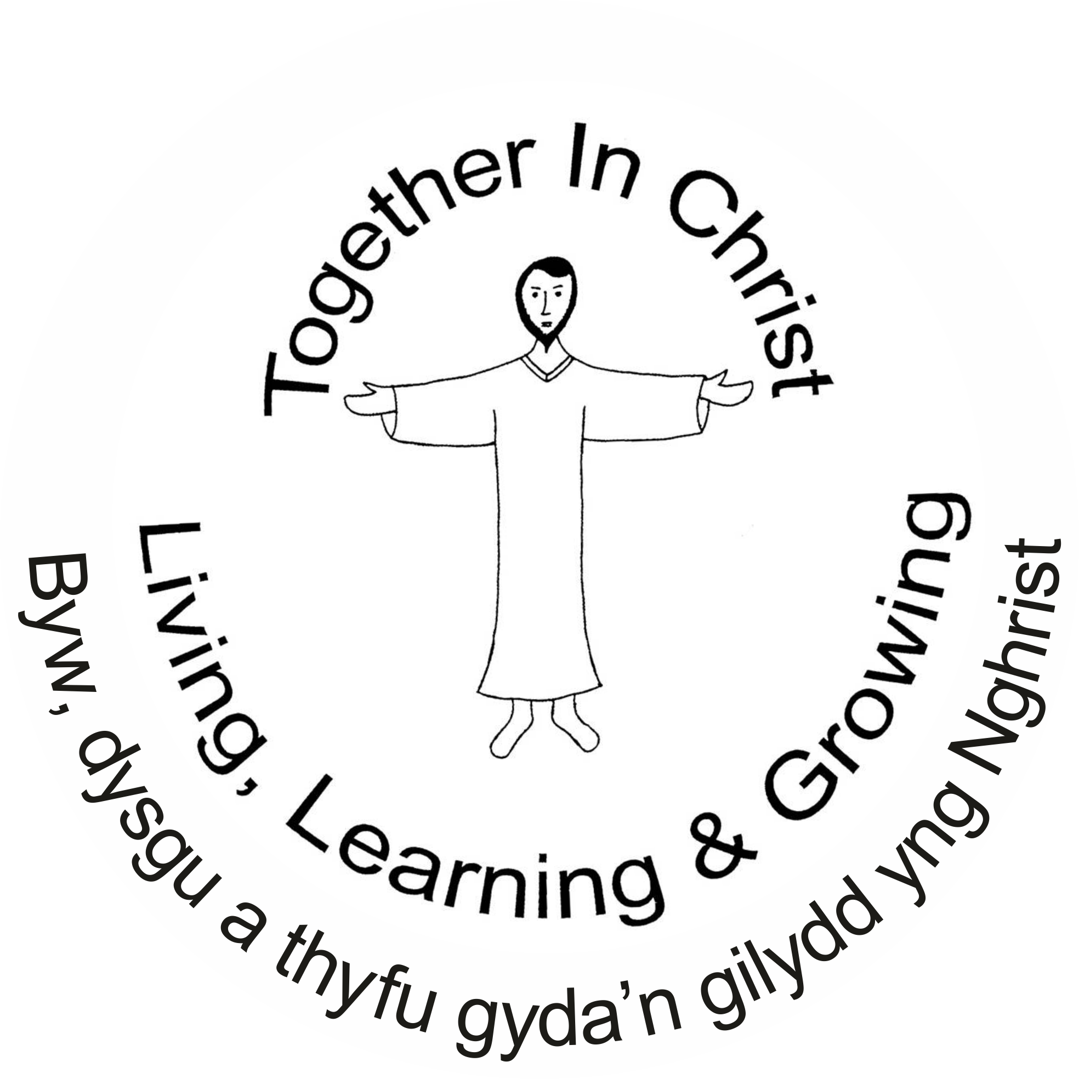
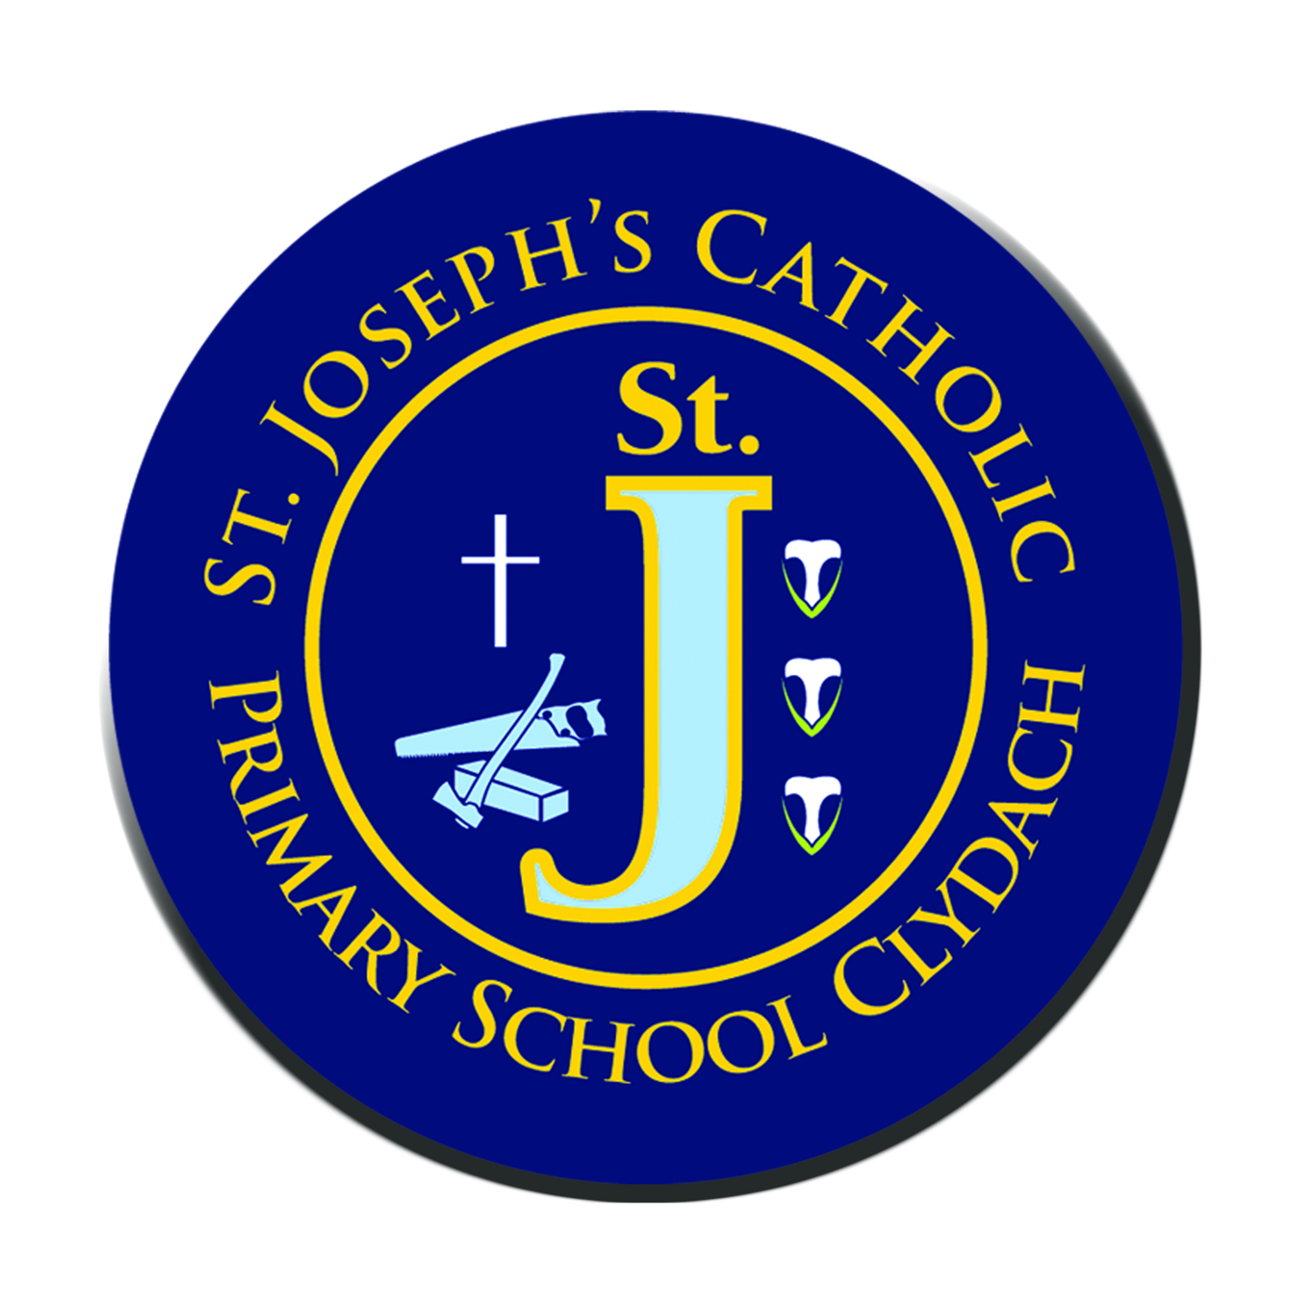


St. Joseph’s Primary School
January 30th 2026
School Attendance: 96.7%
Reception: 93.9% Year 1: 91.7% Year 2: 100%
Year 3: 97% Year 4: 96.9% Year 5: 96.8% Year 6: 100%
Winning Class
for Attendance:
Years 2 & 6:
100%
Ardderchog!

Updates of the week:
Club times are 3.20- 4.20PM Please be on time to collect your child from the main gate, diolch.
MONDAY | TUESDAY
REC/Y1/2: LEGO CLUB | REC/Y1/2: GAMES & FUN
Y3/4: ART CLUB | Y3/4: COMPUTER SKILLS CLUB
GY5/6: CREATIVE WRITING | Y5/6: GAELIC FOOTBALL
I don’t think I have properly introduced Miss Helen James as our new Administration Officer although I know many of you have met/spoken to her. A huge welcome to Helen and a big thanks for all that she has already done.

Confirmation sessions started at St Benedict’s Clydach Sunday 11th January. Mass 10 am then class after Mass. Holy Communion classes have also begun in school Wednesdays 3:20 – 4:00 pm and children must attend Mass weekly.

The ‘Great Athlete’ event was a great success. Thank you so much for your generosity! A large chunk will go to support the work of Great Athletes but we are hoping to have made a good amount to buy new sports equipment for the school. They will be sorting out the prizes etc. when all of the money is in.

The ‘Meet the Head & Deputy’ coffee meeting went well – it was really good to hear parent’s ideas. A parent questionnaire has been sent out also. Please give us your thoughts and ideas. https://forms.office.com/Pages/ResponsePage.aspx?id=Ug4_TzS3ZEGUCRtgHRR5k3vNK9iKGAtOmXqQ7f9jTqhUMTZCNUdDTllQRENBUEwwSEMyRjVQSk9WTy4u

We are leaving Number Day this year to concentrate on World Book Day which we will celebrate on Friday 6th March. Details to follow soon.

Family Mass Sunday 1st March 10am St Benedict’s – all pupils are invited to come in their Welsh costume.

Yr 4 parents – please click on this link for information and the boking link for Annie Jr!!!!!
https://www.j2e.com/st-josephs-catholic-primary-school15/Mary/Annie+Jr.pdf/

Important dates are on the calendar on our school website. The next Inset Day is Monday 23rd February. This is the Monday after Half Term (16th- 20th February)

Please see the important changes to our attendance/absence arrangements. Thank you for your cooperation – https://www.j2e.com/st-josephs-catholic-primary-school15/Mary/Absence+changes+letter.pdf/

Upcoming dates:

Mon 9th Feb – Yr. 5 trip to ‘Big Pit’

Tues 10th Feb – Yr. 6 trip to see ‘Mr. Phormula’

Thurs 12th Feb – Yr 4 visit to Bishop Vaughan

Half Term (16th- 20th February.
Inset Day -Monday 23rd February.

Family Mass Sunday 1st March 10am St Benedict’s – all pupils are invited to come in their Welsh costume.

Jesuit virtues for
January/
February:
Curious & Active



