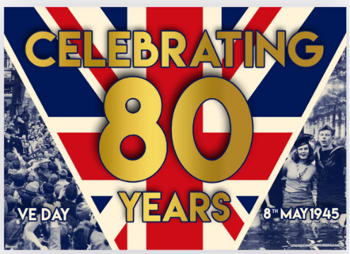
On the 7th of May 1945, Germany surrendered (gave up fighting the war) to Western and Russian military commanders. The next day, the 8th of May, was declared as the official day of celebration. People all over Europe were tired of years of hardship and bombing, they wanted to return to a normal life again.
To commemorate the 80th anniversary of Victory in Europe Day 'VE Day' we will be having a special day. In the morning we will have a special assembly and all classes will learn about an aspect of World War 2 and consider what life was like in the UK in the years immediately after World War Two. For example, stepping into the shoes of a young evacuee or a conscripted soldier looking forward to returning home.
Then, in the afternoon we will have a ‘street party’ with 1940s music and dancing.
Everyone is encouraged to dress up and there are ideas below. Please do not feel obliged to buy an expensive costume. You could wear a bit of red, white and blue!

St Joseph’s Celebrations for
the 80th Anniversary of VE Day
Friday May 9th




