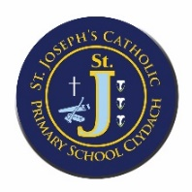
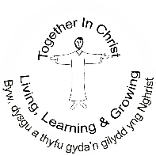
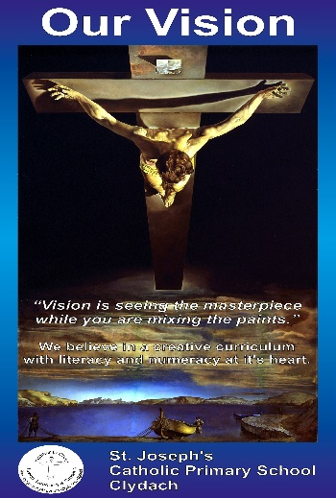

We need to work on:
Priority 1: To continue with the development of the new Religious Education Directory and also begin to introduce the implementation of the new CES Prayer and Liturgy document ‘To Love you more Dearly’, in line with diocesan requirements.
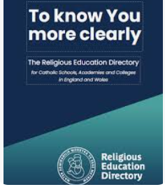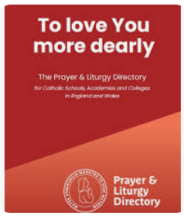
Priority 2: To develop our outdoor learning and improve the use of our outdoors, linking to Science & Technology.

Priority 3: To continue to develop our curriculum design, focussing on progression and coverage in line with our pupils’ needs and experiences. This will involve the use of enquiry research strategies.
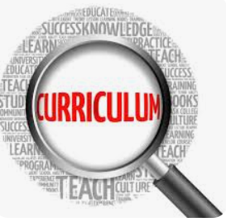

We Celebrate:
We ensure for all staff that there is a high level of professional development and training and encourage a culture of inquiry, innovation and exploration. This underpins our shared vision of a creative curriculum with literacy and numeracy at its heart.

Our Curriculum ensures pupils experience of a global and local dimension which is underpinned by the four core purposes;
Ambitious, capable learners - curious about everything; and active in their engagement with the world, changing whatever they can for the better. -learned, finding God in all things; and wise in the way they use their learning for the common good.
Enterprising, creative contributors - grateful for their own gifts, for the gifts of other people & for the blessings of each day; and generous with their gifts, becoming men & women for others.
Ethical, informed citizens - intentional in the way they live and use the resources of the earth, guided by conscience; and prophetic in the example they set to others. eloquent and truthful in what they say of themselves, the relations between people, and the world.
Healthy, confident individuals - faith filled in their beliefs and hopeful for the future. attentive to their experience and to their vocation; and discerning about the choices they make and the effects of those choices. compassionate towards others, near and far, especially the less fortunate; and loving by their just actions and forgiving words.

Our support of pupils with additional learning needs is strong. A purposeful range of intervention programmes and strategies enables pupils to make good progress in their learning.
The school has a caring, welcoming and inclusive ethos within a safe, secure and stimulating environment. Staff and pupils show considerable respect, care and concern for each other.

At St. Joseph’s our passion for expressive arts under-pins the school’s philosophy, vision, and ethos. Our vision of ‘seeing the masterpiece, while you are mixing the paints’ reflects our creative curriculum with literacy and numeracy at its heart. As a Catholic school we provide an education that is rooted in Gospel Values with Christ at the Centre.
The school’s curriculum is assisted through the use of Curriculum Maestro which we adapted to ensure pupils receive a broad and balanced coverage of the curriculum. Our curriculum has been developed within a Catholic school context and is based on our local identity. We have embedded the virtues within the Catholic Pupil profile across the curriculum and aligned them with the four purposes.
We are an inclusive school with high levels of ALN/ EAL support. We effectively track and monitor pupil progress and maintain good relationships with parents in discussing any support and provision required. As a school we value and respect everyone and pride ourselves in good relationships and a positive ethos.
We work closely with the local Catholic cluster to ensure successful transition of our pupils. We have an open door policy for parents which also includes regular communication through class and weekly newsletters, text alerts and website. Al classes have incorporated online working to support learning at home.
School Development Plan Summary 2024-25

