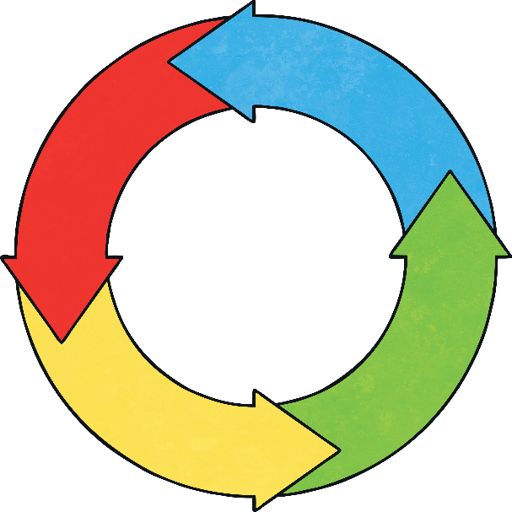
Ambitious, capable learners who:
- set themselves high standards and seek and enjoy challenge;
- are building up a body of knowledge and have the skills to connect and apply that knowledge in different contexts;
- are questioning and enjoy solving problems;
- can communicate effectively in different forms and settings, using both Welsh and English;
- can explain the ideas and concepts they are learning about;
- can use number effectively in different contexts;
- understand how to interpret data and apply mathematical concepts;
- use digital technologies creatively to communicate, find and analyse information;
- undertake research and evaluate critically what they find and are
ready to learn throughout their lives.
Four Core Purposes
Enterprising, creative contributors who:
- connect and apply their knowledge and skills to create ideas and products;
- think creatively to reframe and solve problems;
- identify and grasp opportunities;
- take measured risks;
- lead and play different roles in teams effectively and responsibly;
- express ideas and emotions through different media;
- give of their energy and skills so that other people will benefit and are ready to play a full part in life and work.
Ethical, informed citizens who:
- find, evaluate and use evidence in forming views;
- engage with contemporary issues based upon their knowledge and values;
- understand and exercise their human and democratic responsibilities and rights;
- understand and consider the impact of their actions when making choices and acting;
- are knowledgeable about their culture, community, society and the world, now and in the past;
- respect the needs and rights of others, as a member of a diverse society;
- show their commitment to the sustainability of the planet and are ready to be citizens of Wales and the world.
Healthy, confident individuals who:
- have secure values and are establishing their spiritual and ethical beliefs;
- are building their mental and emotional well-being by developing confidence, resilience and empathy;
- apply knowledge about the impact of diet and exercise on physical and mental health in their daily lives;
- know how to find the information and support to keep safe and take part in physical activity;
- take measured decisions about lifestyle and manage risk;
- have the confidence to participate in performance;
- form positive relationships based upon trust and mutual respect -face and overcome challenge;
- have the skills and knowledge to manage everyday life as independently as they can;
- and are ready to lead fulfilling lives as valued members of society.

